***LED FLASHER LAB FILE***

***Circuit diagram:***

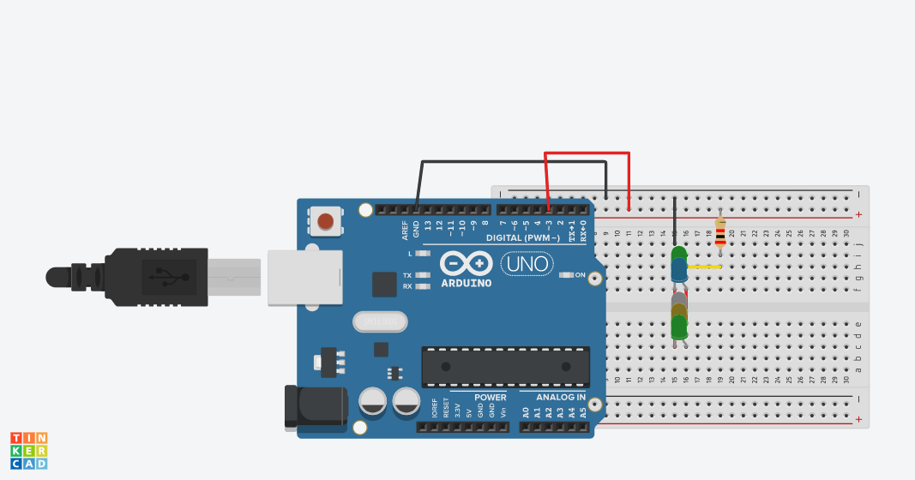

***THEORY:***

***Concept Used:-***

***This includes series and parallel connection circuits by using Kirchoff’s current and voltage law. Many connections using series and parallel connections can be made with many blinking patterns to make our circuit unique.***

***LEARNING AND OBSERVATIOBS:***

***Learnings: -***

* ***To make series and parallel connections on breadboard.***
* ***To do coding on Arduino software.***
* ***Compiling and uploading codes done on Arduino software.***
* ***Use of Arduino and multimeters.***

***Observations: -***

* ***Working of an Arduino.***
* ***Blinking of led lights.***
* ***Software and hardware used for making circuit.***

***PROBLEMS AND TROUBLESHOOTING:***

* ***Uploading and compiling of codes.***
* ***Checking connections and underlining defective led’s.***
* ***Checking correct port for Arduino software and type of Arduino.***
* ***Correct working of various hardware and software used.***

***Precautions:***

* ***Don’t make loose connections.***
* ***Don’t connect Arduino to the respective pc until the circuit is complete.***
* ***Carefully look on the working of all the devices used while making circuit.***

***Outcomes:***

* ***The circuit is complete and glowing led’s in a chasing pattern used is observed.***
* ***Can be used for decorating purpose or any other.***